_____________________________________________________________________________________
Opioid Abuse and Death: Perception from Dayton, Ohio
Name, Excelsior College
_____________________________________________________________________________________

Dayton and its surrounding counties are on top of the list when it comes to deaths from a drug overdose. Ohio is among the ten states that have had a continued increase in overdose deaths in recent years.

Drug abuse and notably opioid is considered a problem by the family physician that is involving health system issues, social health determinants, and multifactorial ones. Everyone knows how severe this crisis is, but it takes an entirely different side if viewed from health care’s perspective. In early July 2019, data released showed that the yearly number of deaths attributed to drug overdoses decreased for the first time for almost 30 years. The drop was accredited to a dwindling in deaths due to opioid painkillers. The news media hailed it as a victory (Daniulaityte et al.,2019).
I have been in Dayton, prescribing narcotics for chronic pain. Later on, I found myself involved in the prescription of opioids to patients who were transferring or retiring physicians started them on. They were all good doctors. A lot of people believe that the prescription of this drug is the leading cause of this pandemic. Indeed, it is an essential factor, but drug overdoses have always been common even before there was an increase in the prescription of the opioid drug. The prescription narcotics have been assertive to both patients and the health care providers causing an increase of acceptance that chronic pain could be maintained with narcotics. I believe that the main cause of death from overdoses are the addictive nature and its readily available nature of the substances.
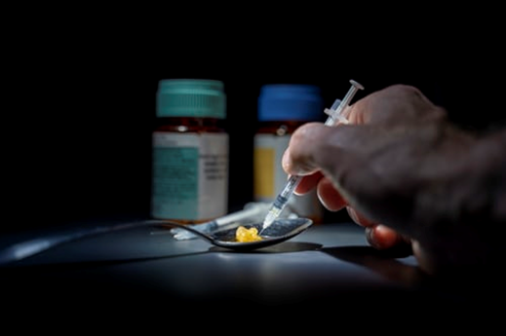
Photo credit: Unsplash.com
The critical factors in drug abuse in Dayton were caused by pessimism for the improvement of life as well as the economic problems. Dayton was a manufacturing city with high output before its economy went down the drain in the early 1970s, causing an increase in unemployment (Bowman,2018). With this, the environment became conducive to drug abuse rise. Being at the crossroad of the two main interstate truck routes, ready access to the illegal trade of drugs is allowed. A lot of the opioid users are physical laborers as well as construction workers as much as it is hard to have people working on top of roofs while taking opioids. Looking at their bruised joints, it is understandable that relief for pain can be different between their working ability and a life without enough income.
As a physician, the challenge is on how to assist patients on chronic opioids for pain and the ones that are drug addicts. The two groups require different handling methods. A number of the patients on the prescribed opioids have been on them for many years, without notable evidence of having problematic addiction. Notably, the treatment for the addicts will be different, for they will try getting the prescription from health care workers or the streets leading to the overdoses. My goal is to personally identify where patients are on this scope to best assist them
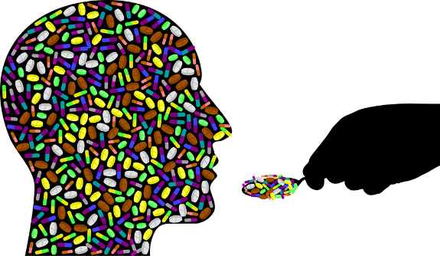
Photo credit: pixabay.com
Despite the problems, we as physicians should keep doing what we do best that is working with our patients. For us to tackle the problem, we need to partner up by providing support and giving correct treatment. We will slowly observe improvements. Chronic illness requires a lot of interventions. As time goes by, a relapse will become a part of learning how to maintain change. For the academic physicians, students, as well as residents, the opiate abuse pandemic, incorporate a medical and public health component that creates a call to action. We can petition to improve the many rules, policies, and regulations that hurt the nation's capacity to prevent commencement and stop the ongoing drug abuse. Within our vicinity, using the right training in the medical schools and residencies is a must-do. Withal, enhancing our ability to know what to do, we should be able to bring a fantastic force of the research in real-life situations and conditions to assist all possible layers needing action.
Between our potential in influencing our future health care workforce training, our research ability, and the drive to make a change for the patients, we physicians can and should make a real impression in the respects of the disheartening and horrific effects of opioid and other addictive drugs misuse and abuse. This is because upcoming in Ohio and some states is another under the looked and overlapping issue that is marijuana.

References
Bowman, M. (2018). Opioid Abuse and Death: Thoughts From Dayton, Ohio. Family medicine, 50(6), 420-422.
Daniulaityte, R., Nahhas, R. W., Silverstein, S., Martins, S., Zaragoza, A., Moeller, A., & Carlson, R. G. (2019). Patterns of non-prescribed buprenorphine and other opioid use among individuals with opioid use disorder: A latent class analysis. Drug and Alcohol Dependence, 204, 107574.

